**Split Shipments Case Study**

We face many interesting supply chain problems. We hope that the following case, based on one of OUR BUSINESS’s actual supply chain initiatives, gives you helpful insight into the challenging analytical problems we tackle with us.

# Background

You have recently joined our Supply Chain Science team. You learn that in addition to two main distribution centers (DCs), we expanded its supply chain network to include strategically located, third-party operated (3PL) distribution fulfillment facilities located in Boston, Chicago, Los Angeles and Jacksonville (see the map below). The purpose of adding these locations is to increase the speed of deliveries to customers (web and store) while decreasing split-shipments and lowering shipment costs.

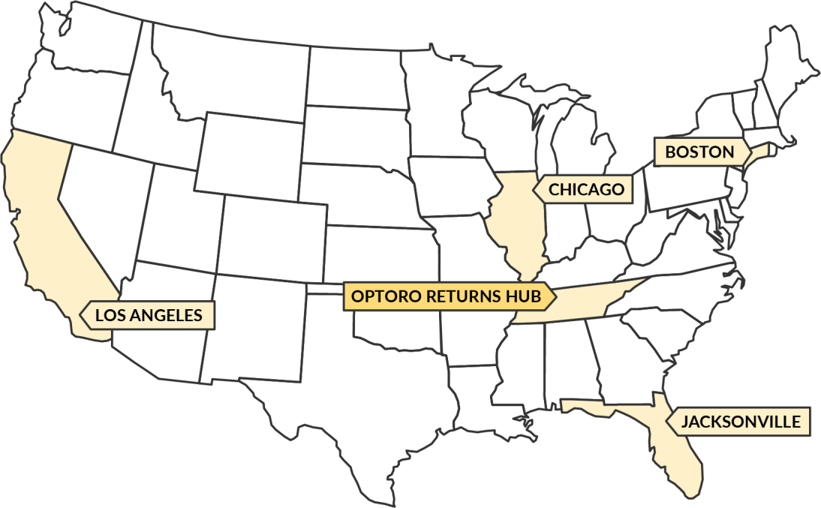

Each 3PL is intended to fulfill the orders placed by customers from the geographical distance closest to it. For instance, Boston 3PL should fulfill the orders that are placed by customers in the zip codes closest to Boston. In addition to the distance, another priority is sending orders via only one shipment because of the high cost of multiple shipments. There are cases when one 3PL does not carry all the SKUs in an order, so the order will be delivered to the customer through multiple shipments from multiple 3PLs. So, an ideal case for fulfilling an order would be shipping it in one package and from the closest 3PL. As a result, an order may be fulfilled in three different ways in terms of splits and closeness to 3PLs:

*SRM Technologies – Confidential 1*

*Supply Chain Strategy, Planning, & Execution*

**Type 1 - non-split shipment (fulfilled from the closest 3PL)**: the order is delivered to the customer by a single shipment from the closest 3PL.

**Type 2 - non-split shipment (fulfilled from a non-closest 3PL):** the order is shipped to the customer in a single shipment from the 3PL that is not the closest one to the customer location.

**Type 3 - split shipment**: the order is shipped to the customer in multiple shipments from different 3PLs.

We would ideally like all the fulfilled orders to be Type 1. Otherwise, Type 2 would be preferred. We most want to avoid having Type 3 orders. **So, the question is: How we can increase the number of Type 1 & Type 2 shipments and reduce Type 3 shipments in all the orders fulfilled by 3PLs?**

# Task

## Part 1

You are part of a task force team that aims to conduct a root cause analysis on factors that contribute to Type 3 shipments and eventually propose approaches that can be taken to reduce them. We would like to understand how you would approach conducting a root cause analysis and solving the problem. Please be ready to talk about the tools and techniques that you are likely going to use.

If you have any questions or need clarification on the questions, please do not hesitate to reach out to venkateshkannappan@srmtech.com or call him at 9500042930

Good luck,

SRM Technologies

Supply Chain Science Team

*SRM Technologies – Confidential 2*

*Supply Chain Strategy, Planning, & Execution*